**STUFFED CABBAGE, LIGURIAN-STYLE**

**MOLTO BATALI (ECCO 2011)**

[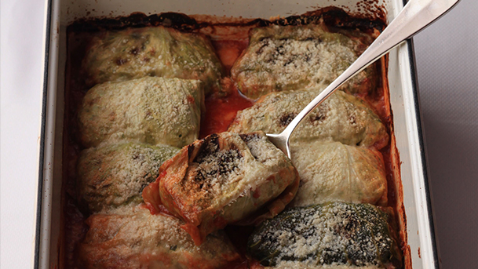](http://www.mariobatali.com/wp-content/uploads/2014/01/PostImage_Stuffed-Cabbage.jpg)

[Read more about cabbage…](http://www.mariobatali.com/cruciferous/)

**INGREDIENTS**

*Makes 12 rolls; Serves 8 to 10 as a side dish or an antipasto*

[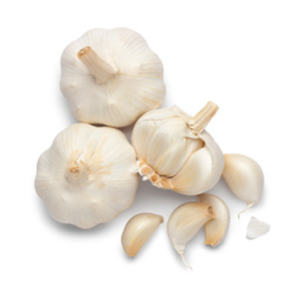](http://www.mariobatali.com/tag/garlic/)

[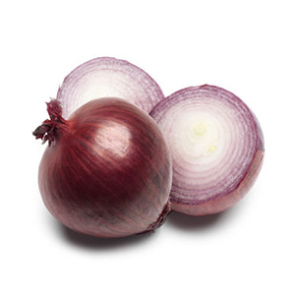](http://www.mariobatali.com/tag/red-onion/)

[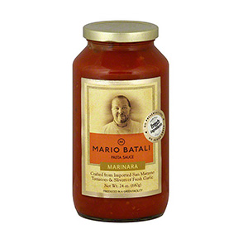](http://www.mariobatali.com/tag/tomato-sauce/)

1 large green cabbage (3 to 4 pounds)

Salt

6 tablespoons extra virgin olive oil

2 medium red onions, [cut into 1/2-inch dices](http://www.mariobatali.com/videos/chop-onions/) 

6 garlic cloves, thinly sliced

1 pound new potatoes, scrubbed and cut into 1/4-inch dice

Freshly ground black pepper

1 cup fresh ricotta, drained

About 1 cup finely slivered fresh basil leaves

1/4 cup finely chopped fresh Italian parsley

2 cups basic tomato sauce (for quick results, try my [Mario Batali pasta sauces by Gia Russa](http://www.mariobatali.com/products/pure-natural-pasta-sauces/))

1/2 cup freshly grated Pecorino Romano

**DIRECTIONS**

Preheat the oven to 375 F.

Bring 8 quarts of water to a boil in a large pasta pot. Fill a large bowl with cool water, and place it nearby.

Remove the tough outer leaves of the cabbage, finely chop them, and set them aside. Carefully cut out the cabbage core with a sharp knife.

Add 2 tablespoons salt to the boiling water. Drop the whole cabbage into the water and cook until it is tender, 5 to 6 minutes. Then transfer the cabbage to the bowl of cool water and let it cool.

When the cabbage is cool enough to handle, drain it. Carefully remove the whole leaves from the head, and set aside about a dozen of the best and largest. Chop the remaining cabbage into 1/4-inch pieces and set them aside.

In a large, heavy-bottomed pot, heat the oil over medium heat until just smoking. Add the onions, garlic, potatoes, and the raw and cooked chopped cabbage. Cook, stirring occasionally, until the vegetables are very soft, 12 to 15 minutes. Season with salt and pepper to taste, and allow to cool.

When the potato mixture is cool, add the ricotta, basil and parsley, and fold together. Place a scant 1/2 cup of the cabbage/ricotta mixture in the center of each whole cabbage leaf. Fold each leaf around the filling like a burrito, and secure it with a toothpick.

Pour the tomato sauce into a 9- by 13-inch baking dish, and arrange the cabbage packets on top. Cover the dish tightly with foil, and bake for 30 minutes.

Remove the foil, sprinkle the cabbage packets with the grated pecorino, and bake for another 10 minutes. Serve warm or at room temperature.